**Focus keyword**: Good Morning Exercise

**Meta Title:** Good Morning Exercise – vigoursoul

**Meta Description:** Good Morning Exercise is a weightlifting workout that engages your entire body's muscles.

**Feature Image:**

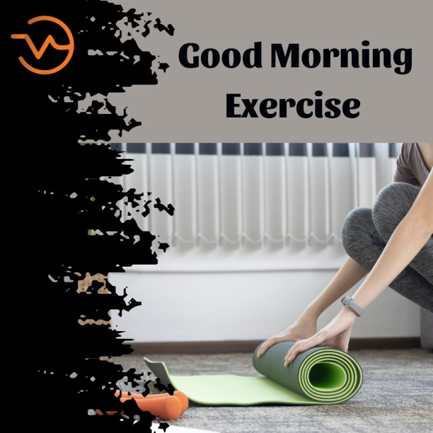

**Good Morning Exercises**

A weight training exercise is the good-morning. A good morning is referred to as such because of the movement of the erector spinae, which mimics the bow that several East Asian nations traditionally employ to start the school day. While the hamstrings and gluteus maximus operate isotonically to produce hip extension, the erector spinae muscles of the lower back work isometrically to maintain the spine's extended posture. The stabilization of weight on the spine and preservation of balance need additional muscles.

**What Is Good Morning Exercise?**

The **Good Morning Exercise** is a weightlifting exercise that works every muscle in your body. Stand with your feet shoulder-width apart and do some morning exercises. In a position similar to a back squat, unrack a weighted barbell and place it on your upper back. Inhale deeply, tighten your abdominals, and swing your hips rearward. Lower your upper body then hinge forward to stand back up.

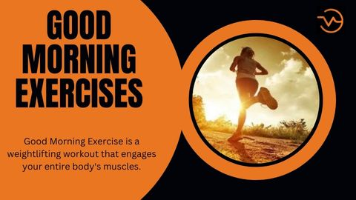

The good-morning exercise is contentious because some people believe it causes lower back issues. Famously, Bruce Lee had a significant injury while completing the exercise as a result of a poor warm-up and an overly confident choice of working weight. On the other hand, when done correctly, the good-morning stretch may help strengthen the lower back and shield it from harm.

Back injuries can occur when the back is rounded. During the lift, it's standard practice to fix the eyes on a location approximately belt height, then reverse direction after lowering when the eyes line up with the spot. This helps to maintain a flat or slightly arched spine at the bottom of the range of motion by maintaining the chin up and the head inclined back.

**How to Perform the Good Morning Workout Properly**

Start the **Good Morning Exercise** by performing 2-3 sets of 8–12 repetitions with a weight that you can control. Select a weight that enables you to maintain proper form through all sets and repetitions.



* Adjust a barbell in the squat rack to the proper height based on your height. Your shoulders and the barbell should be at a small angle.
* With your back to the barbell, stand underneath it and set your hands on either side. Your upper back muscles should support the barbell as it rests there.
* Remove the barbell off the rack and advance a few steps.
* Keep your posture upright, your feet hip-width apart, and your knees slightly bent. With a neutral head and neck position, your shoulders should be precisely over your hips. Throughout the movement, your chin should remain tucked, as if you were keeping an egg there.
* To create a secure foot position, grip the ground with your feet. The entire surface of each foot should bear the same amount of weight.
* Rotate your shoulders outward to work your upper back and lats.
* Engage your core while pretensioning your shoulders and hips. You should have your pelvis somewhat tucked in and your ribs should be down.
* Starting with your hips hinged to push your hips backward, move backward while keeping your spine neutral.
* Push your hips backward and allow your upper body to move forward until it is 30 to 45 degrees off the ground.
* Keep your shins vertical and your knees slightly bent. Your glutes and hamstrings ought to feel stretched.
* At the end of the backward motion, take a brief pause.

**Dumbbell Good Morning Exercise**

Standing with your feet hip-width apart, **Good Morning Exercise** grab two dumbbells with a slight bend in your knees. With your palms facing inward, hold the weights at shoulder height.

A dumbbell should be held in each hand as you stand with your feet hip-width apart and your knees slightly bent. Lift the dumbbells and position them so that your shoulder blades are resting on them. Push your hips back and hinge your upper body until it is nearly parallel to the floor while keeping your knees slightly bent.

Without altering the angle of your knees, hinge at your hips and lower your torso until it is almost parallel to the floor. Retrace your steps to where you were before pausing. The repetition ends there. As you perform the exercise, try not to let your lower back arch.

**Good Morning Exercise Muscles**

More than just a shirt filler, a big, strong chest adds structure to your body. Every athletic activity where you project force forward, such as tossing a ball, punching an opponent, or pushing someone out of the way, benefits from having strong chest muscles.

Your torso's frame is made up of your chest muscles, shoulders, upper back, and arms, and it greatly affects how you appear to others. Therefore, developing large, muscular pecs is crucial whether your goal is to increase athletics or develop a classic body.

## You'll discover how to successfully Good Morning Exercise your chest in this post. From chest muscle structure and development to the tried-and-true routines used by lifters, bodybuilders, and athletes for ecades to achieve their goals.

## Good Morning Exercise Alternatives

## Good Morning Exercise with a barbell may not be to everyone's taste. The technique could be challenging for people whose shoulders or lower back are not mobile. There are additional options that also focus on the posterior chain, which is good news.

## Here are six different ways to say good morning, which we all like.

**Different Back Extensions**

The muscles used in the g **Good Morning Exercise** are also worked out with back extensions done at 45- or 90-degree angles. They are also a good choice for strengthening the hips and lower back, which can result in deadlift lockouts that are more effective.

**Reverse Hyperextensions**

Reverse hyperextensions are great **Good Morning Exercise** for developing hip and hamstring strength as well as lower back stability and stability. This variation isolates the glutes and hamstrings for more focused muscle building and is generally safer because you don't need to load the muscles with weight to induce growth.

Anyone who has problems with their knees, hips, shoulders, or any other joint that would prevent them from performing barbell good mornings should try this version.

**Hip Thrusts**

Regardless of the variety, hip thrusts are a great approach to improve glute bulk, hip flexion and extension mechanics, and hip extension strength.

However, because your knees are bent at a 90-degree angle, **Good Morning Exercise** let your hip thrusts don't incorporate as much of your hamstrings and lower back. This isn't always a bad thing, but you should be aware of it so that you don't skip other exercises that target your hamstrings and lower back.

**Glute-Ham Raises**

The glute-ham rise is a fantastic workout that may be done for more repetitions to develop glute, hamstring, and lower back hypertrophy. It would be beneficial for you to see the following tutorial video from Rogue's YouTube channel if you have never done this workout before.

You should increase the weight or resistance of this **Good Morning Exercise** after you can complete the reps using only your bodyweight (plates, bands, or chains). Your posterior gains will increase as a result, but be careful to only slightly raise the weight.

**Resistance Band Hello there**

With a resistance band in place of the barbell, you may perform a decent morning exercise with all its health benefits without having to deal with the barbell's compressive stress on your back. The band is less uncomfortable on your upper back and shoulders than it is on your neck, though a pad might assist with that.

The best way to perform this **Good Morning Exercise** is for greater repetitions as a hamstring finisher or as a warm-up before more difficult or demanding hip hinge exercises.

**Chinese plank in reverse**

This **Good Morning Exercise** is not for laughs. It is a challenging isometric exercise that concentrates on the posterior chain as a whole. Use of two benches, boxes, or a mix of both is required for the exercise.

You lie elevated face-up with one bench under your shoulders and the other under your heels. It's totally up to the lower back, glutes, and hamstrings to keep you from collapsing to the floor because only your heels and upper back are providing any support.

## Good Morning Exercise Benefits

## If you want to give the good morning a try, go for it. Use a PVC pipe to test your form to see if it is secure enough to perform a Good Morning Exercise safely. Standing tall, secure the PVC pipe (or stick or broomstick) behind your back with one arm behind your head and the other behind your back.

## Your strength training programme may offer the following advantages by including good morning exercises:

## Good Morning Exercises (4).jpg

## Morning stretches strengthen the posterior chain. The good morning exercise targets the erector spinae, gluteus maximus, hamstrings, and lower back muscles, which are located on the backside of your body. Exercises you do in the morning can strengthen your back and legs if you do them correctly.

## Morning exercises can improve the way your hips hinge. Your performance during other hip-hinging exercises like the Romanian deadlift and the kettlebell swing will be enhanced as a result of the good morning exercise's ability to increase your hip extension and flexion strength.

## Morning exercises can help with posture. The Good Morning Exercise can improve your posture while engaging in daily activities and increase muscle hypertrophy along your back with regular practice.

## From the posterior pelvis upwards up the entire spine, the spinal erectors are located. They are essential in maintaining the spine's structural integrity under pressure and aid in preventing spinal flexion, which can happen during squat and deadlift variants.

## A tree leans to one side when its top becomes too hefty. To correct this, secure a rope to the ground on the opposite side and attach it to a stake to give the tree more stability to stand straight. Similar functions are performed by the spinal erectors to keep the spine stable during loaded and unloaded movements.

**Barbell Good Morning Exercise**

With this **Good Morning Exercise**, your hamstrings (back of the leg) are the main target, but other muscle groups benefit as well. Your erector spinae, which runs the length of your spine, serves as a stabilizer while your gluteus maximus and adductor magnus, located in your buttocks and inner thighs, cooperate.

As antagonist stabilizers, your rectus abdominis and obliques (abdominal muscles) are used. Good mornings are an excellent technique to increase the strength in your legs, hips, and back because they use all of these muscle groups.

Utilizing a weighted barbell increases the load and further engages these muscles. According to research, using at least 50% of your one-repetition maximum increases knee flexion and the activation of the hamstrings and spinal erectors.

**Good Morning Exercises-FAQS**

**Barbell excellent mornings work what?**

The **Good Morning Exercise** strengthens the back, glutes, hamstrings, and abs. The strain on these muscles is increased while using a weighted barbell, but beginners should begin with a moderate weight (or no weight at all). Your lower body and core strength training programme should include the barbell good morning.

**Are good mornings a worthwhile endeavour?**

The good morning exercise is a back exercise with great effectiveness that also works the glutes and hamstrings. It's a great addition to any posterior chain workout regimen thanks to its variations and distinctive muscle activation patterns. The good morning greatly depends on the hip hinge.

**What does "good morning workout" mean?**

Fun fact: The **Good Morning Exercise** received its name because the motion resembles a "good morning" bow made at the waist. The Good Morning, however, is one of the best exercises for strengthening your lower back, hamstrings, and glutes.

**Do good mornings promote health?**

The muscles in the posterior chain, often known as the muscles on the back of the body, including as the upper back, lats, and calves, are all strengthened by excellent mornings in addition to your glutes and hamstrings.

**Conclusion**

The **Good Morning Exercise** targets the hamstrings, gluteus maximus, erector spinae, and lower back muscles down the back of your body. Good morning workouts can strengthen your back and legs if done correctly.

The **Good Morning Exercise** is a back exercise with great effectiveness that also works the glutes and hamstrings. It's a terrific supplement to any posterior chain workout regimen thanks to its variants and distinctive muscle activation patterns.